|  |  |
| --- | --- |
| **Date** | **15th April 2023** |
| **Team ID** | **NM2023TMID16771** |
| **Project Name** | **Recruiting Assistant for HR Managers** |
| **Team Leader** | **SNEHA.P** |
| **Team Member** | **NIVETHA.R** |
| **PAVITHRA.R** |
| **NARMATHA.M** |

1. **INTRODUCTION**
   1. **. Overview**

Human resource management is a function in organizations designed to maximize employee performance in service of their employer.

* 1. **. purpose**

HR is primarily concerned with how people are managed within organizations, focusing on policies and systems. HR departments and units in organizations are typically responsible.

1. **PROBLEM DEFINITION & DESING THINKING**

**2.1. Empathy map**

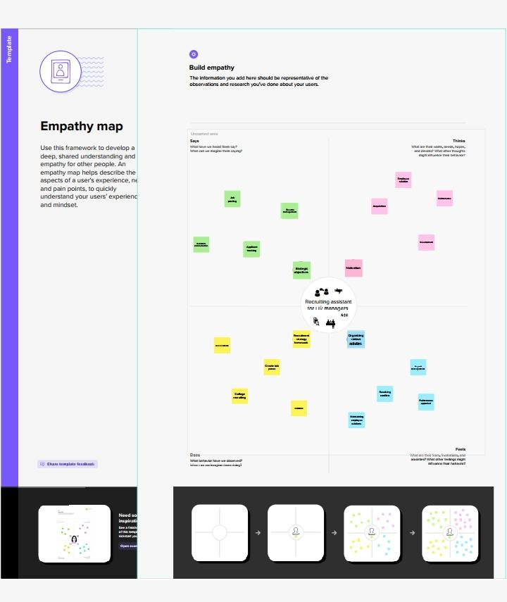

**2.2. Ideation & Brainstorming Map**

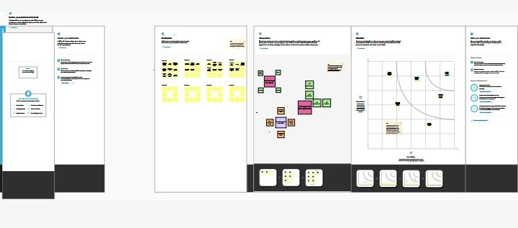

1. **RESULT**

**3.1. Data Model:**

|  |  |  |
| --- | --- | --- |
| **Object Name** | **Fields in the Object** | |
| **Field Label** | **Data Type** |
| Job posting site | **Status** | **URL** |
| **Technical Site** | **URL** |
| **Description** | **URL** |
| **Job Posting Site URL** | **URL** |
| **Phone Number** | **Phone** |
| Review | **-** | **-** |

Miles

**3.2. Activity & Screenshot**

Milestone 1: 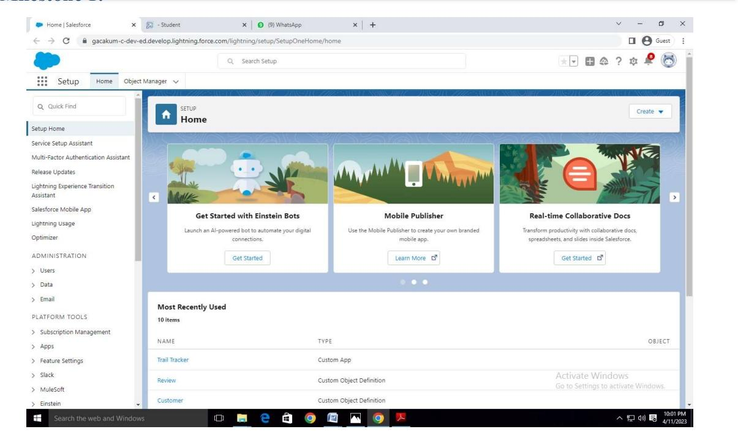Milestone 2: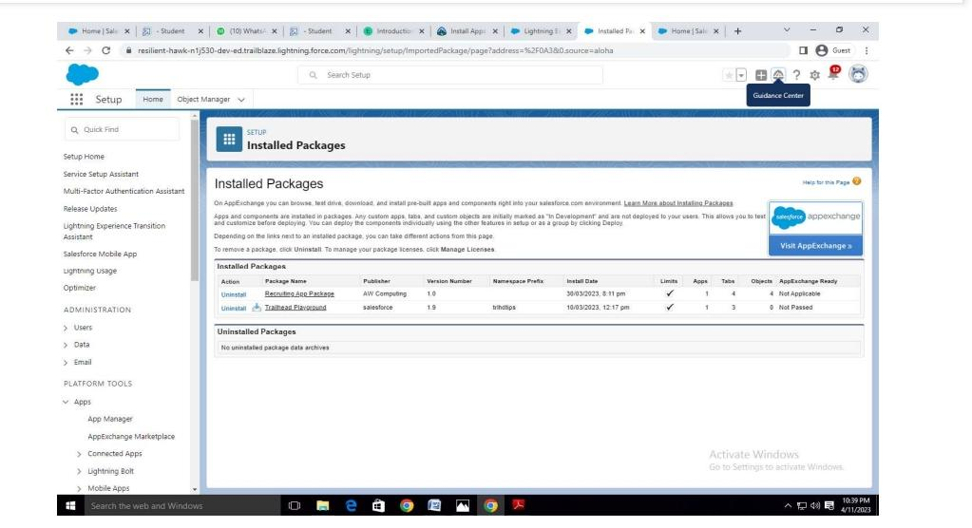

Milestone 3: 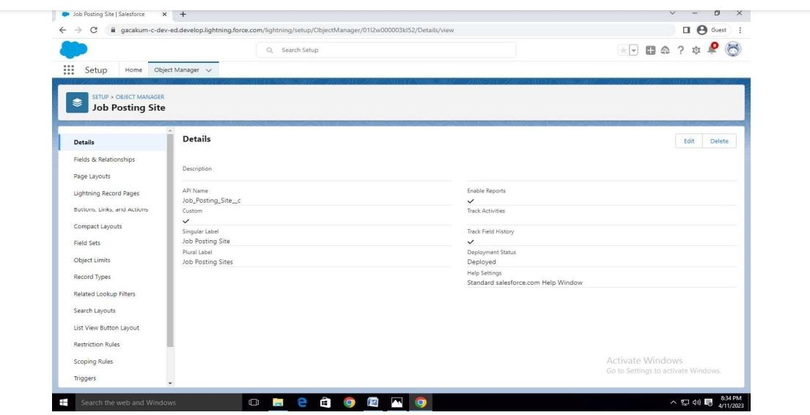

Milestone 4: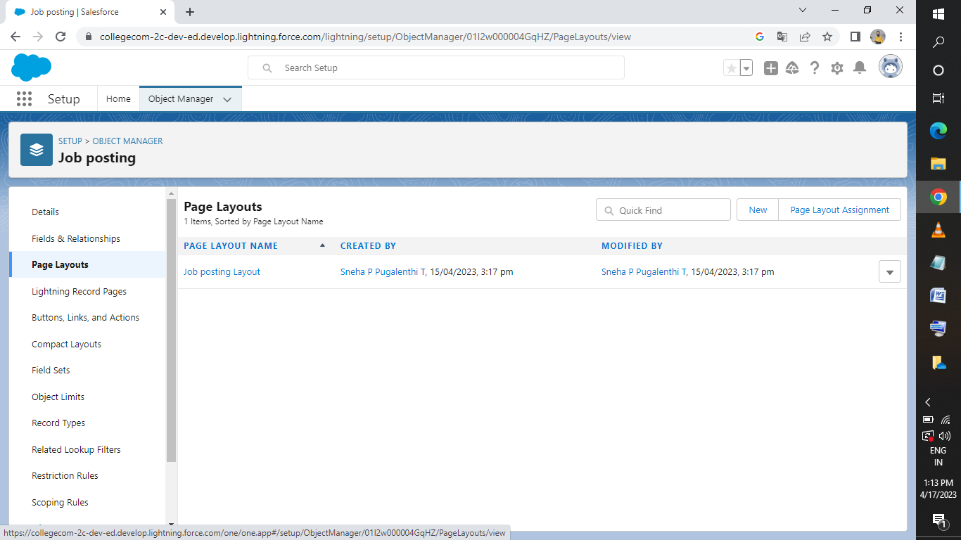

Milestone 5:

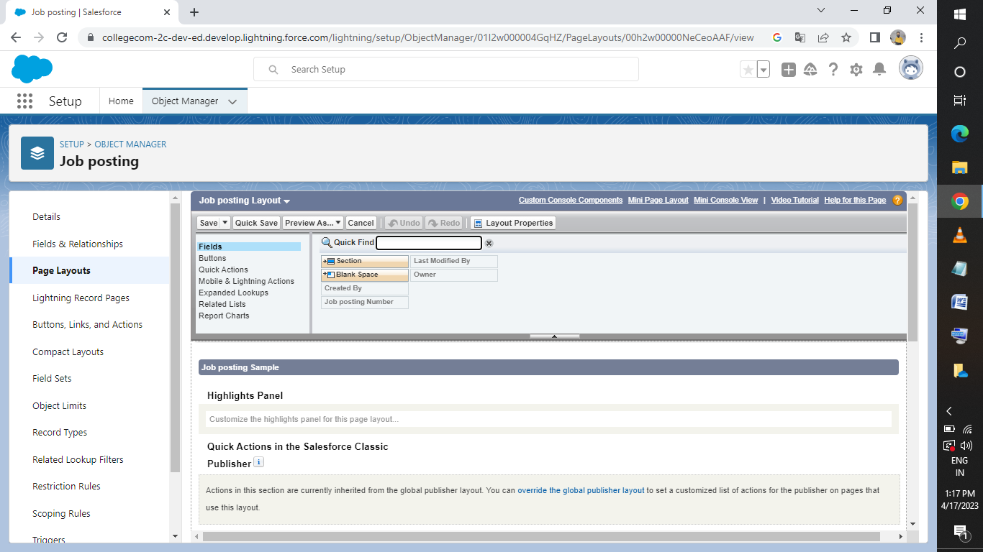

Milestone 6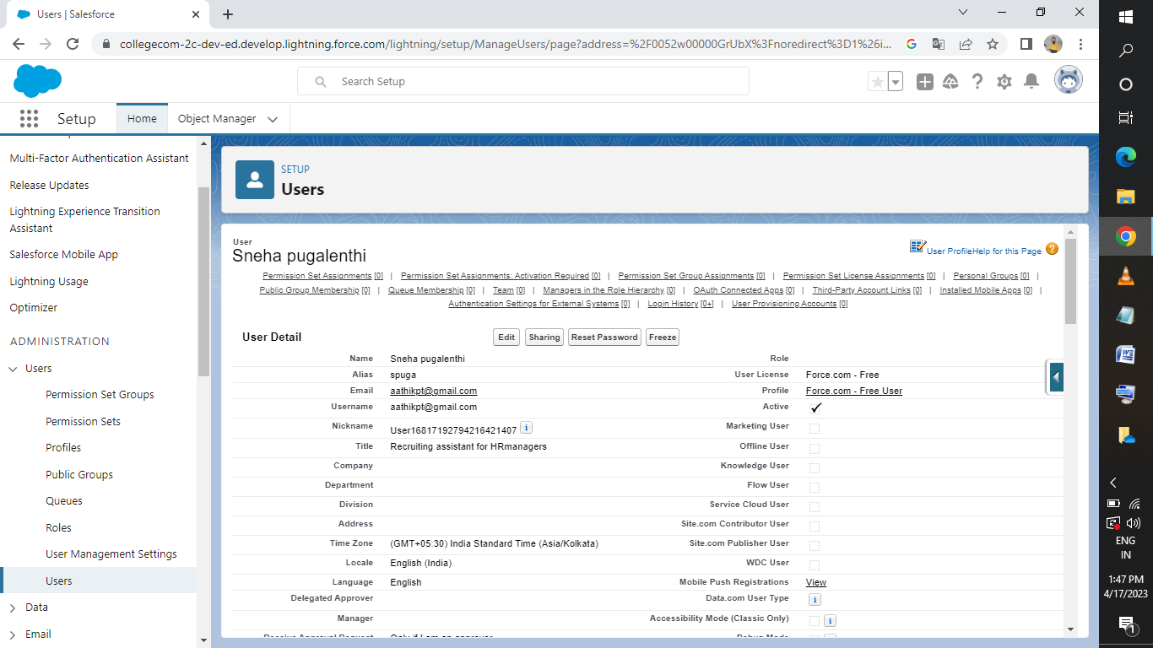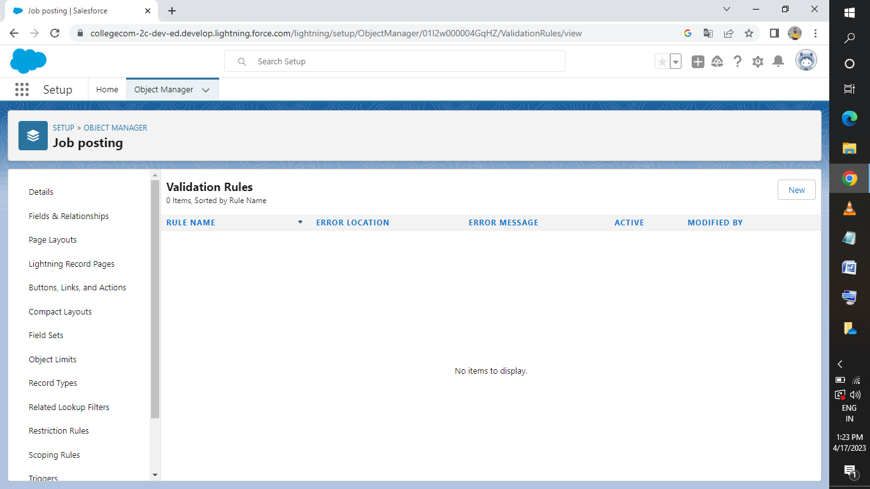Milestone 7:****

Milestone 8:



Milestone 9: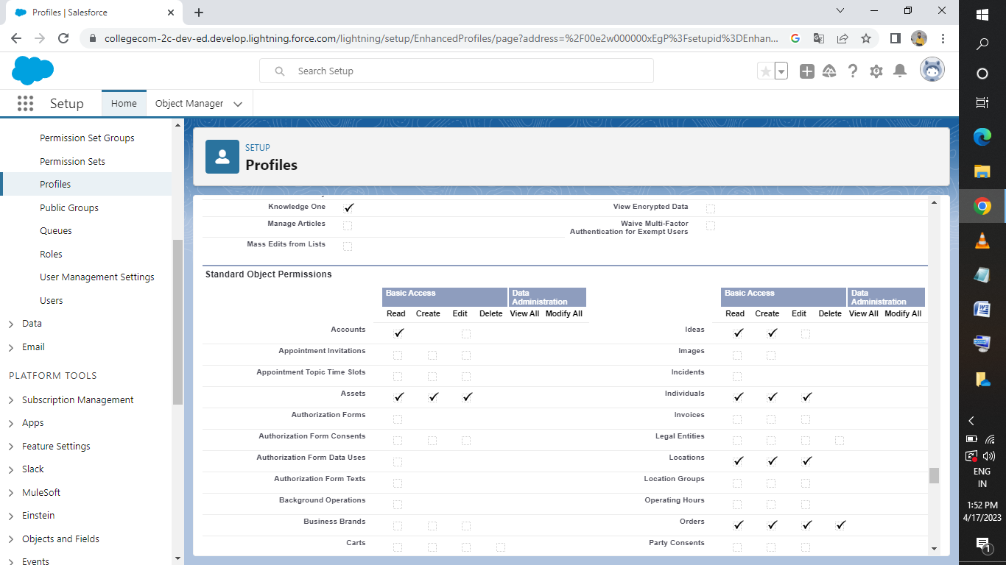Milestone 10: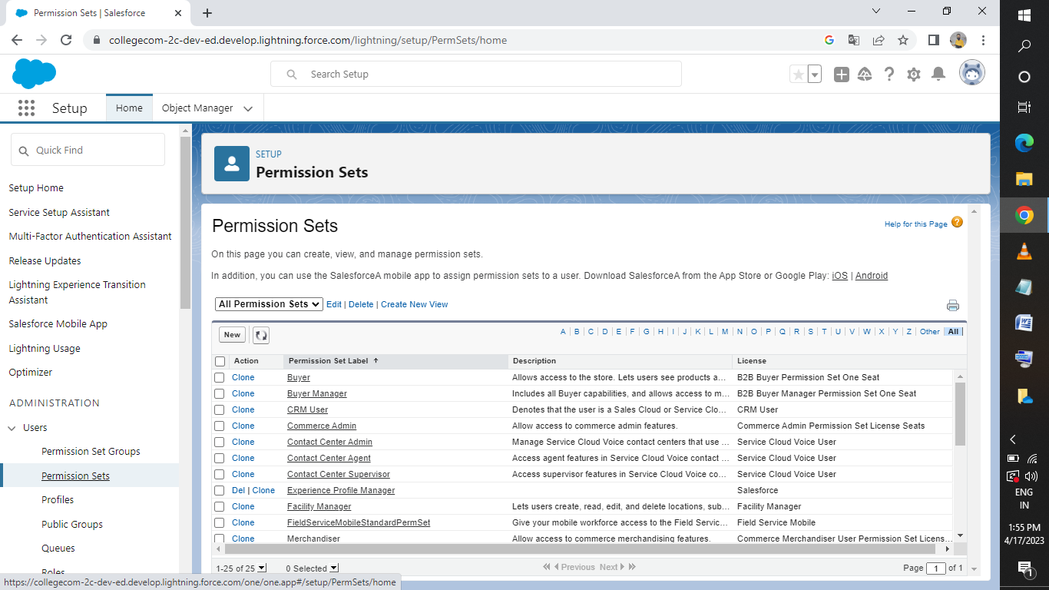

Milestone 11: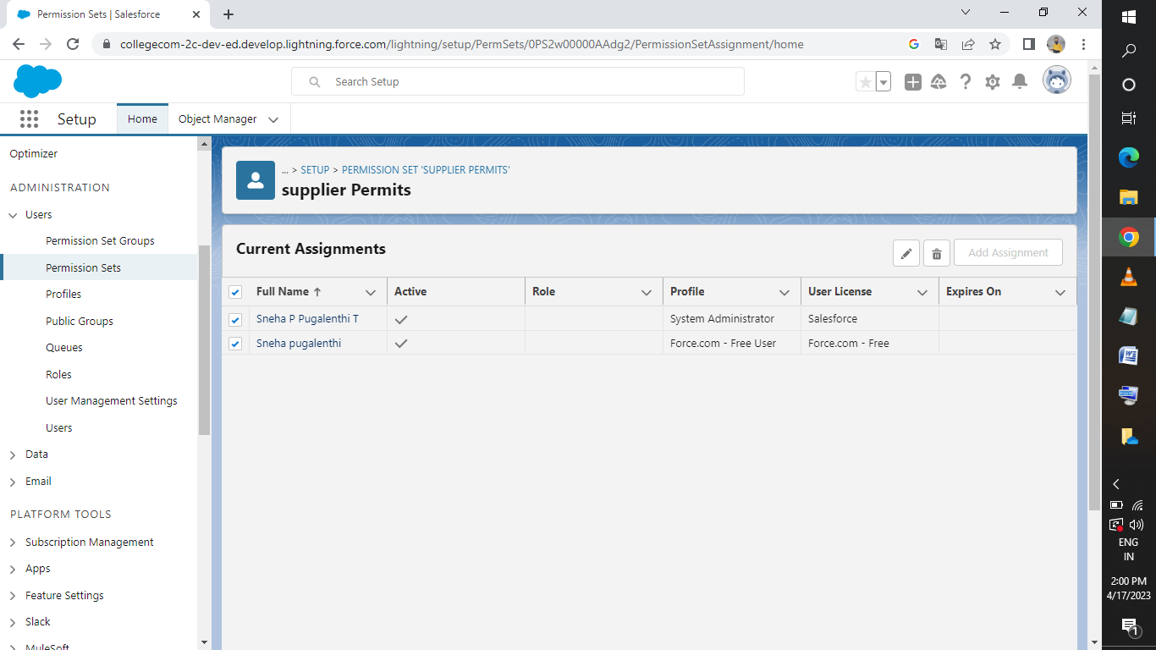

1. **TRAILHEAD PROFILE PUBLIC URL**

**Team Lead** – <http://trailblazer.me/id/spugalenthit>

**Team Member 1** – <http://trailblazer.me/id/niveer24>

**Team Member 2** – <http://trailblazer.me/id/pavir40>

**Team Member 3** – <http://trailblazer.me/id/narmm6>

1. **ADVANTAGES & DISADVANTAGE**

**Advantages:**

* Cover all of your departemental needs and application requirements in one all inclusive suite.
* Only one vendor to deal with.
* Can more easily scale with your business.
* Greater functionality for manufacturing processes.

**Disadvantages:**

* Manufacturing applications might lack certain features critical to some industries or niches.
* Can be difficult to customize.
* Might be overkill for some smaller Manufactures.
* Might have integration issues with administrative applications and ERP system may still be necessary to cover administrative functions.

1. **APPLICATIONS**

* To understand the concept of the sales organization, and the basic types of sales organizations.
* To determine the size of the sales force by using various methods.
* To realize the importance of the various steps included in planning recruiting and selection stages.

1. **CONCLUSION**

* Polices adoped by EMC are transparent, legal and scientific.
* Recruitment is fair.
* The recruitment should not be healthy.
* To some extent a clear picture of the required candidate should for appropriate candidates.

1. **FUTURE SCOPE**

The scope of the research is very vast; however the total time period available was very limited for the purpose of the study observation, analysis and conclusion.